Commander Richard Wainwright
1817-1862
Commander Richard Wainwright was born in Charlestown, Massachusetts in 1817.
Commander Wainwright, a cousin of Commander Jonathan Mayhew Wainwright, was commissioned in the US Navy on 11 May 1831.
Between 1841 and 1857, Wainwright served in the Coast Survey and on the Navy's Home Station. He cruised in Merrimack on special service from 1857 to 1860.
Following the outbreak of the Civil War, Wainwright commanded USS Hartford, flagship of Admiral David G. Farragut's West Gulf Blockading Squadron. During the passage of forts below New Orleans on the night of 24 and 25 April 1861, he performed gallant service in extinguishing a fire on Hartford while continuing the bombardment of the forts. Commended by Admiral Farragut for his actions, Wainwright later participated in the squadrons operations below Vicksburg until taken ill with fever.
He died in New Orleans on 10 August 1862.

Commander Jonathan Mayhew Wainwright
1821-1863
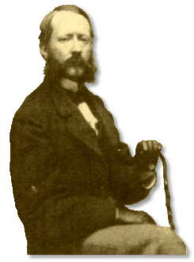
Commander Jonathan Mayhew Wainwright was born in New York City, New York in 27 July 1821.
Commander Wainwright was initially commissioned in the US Navy on 30 June 1837 and served with distinction in the Civil War. Wainwright commanded USS Harriet Lane, Admiral David Dixon Porter's flagship, in an engagement at Forts Jackson and St. Philip and took part in operations below Vicksburg. He was killed in an attack upon Confederate forts in Galveston Harbor on 1 January 1863.
He died in New Orleans on 10 August 1862.

Image courtesy: United States Army Military History Institute

Rear Admiral Richard Wainwright
1849-1926
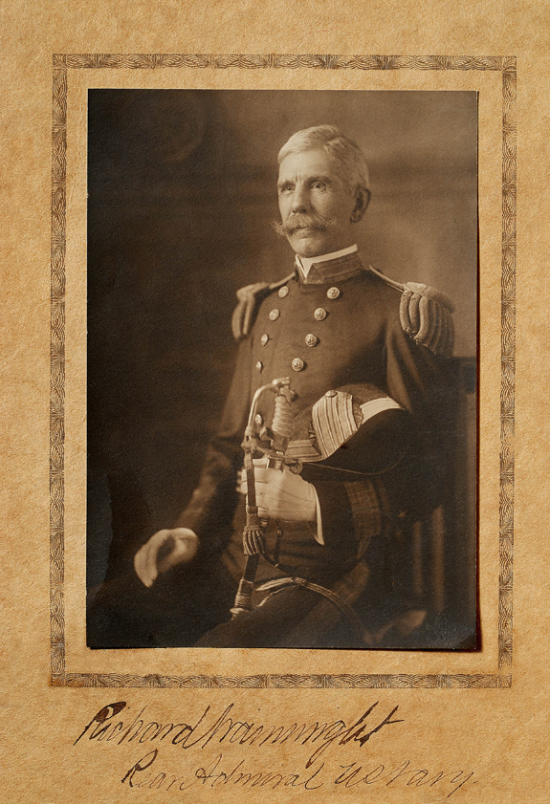
Rear Admiral Richard Wainwright was born in Washington, DC on 17 December 1849.
Rear Admiral Richard Wainwright, the son of Commander Richard Wainwright, was commissioned in the US Navy on 28 September 1864.
Wainwright was Executive Officer of the battleship USS Maine when she blew up in the harbor of Havana, Cuba, on 15 February 1898. Surviving the explosion he was assigned to command of the tender Fern and was in charge of the recovery of the bodies of the victims. He also assisted in the collection of information for the subsequent court inquiry.
Wainwright later commanded the wooden gunboat USS Gloucester at the battle of Santiago on 3 July 1898. In this engagement, Gloucester sank one Spanish torpedo boat and drove another on the beach. Wainwright was commended for his valor in this engagement.
Later, promoted to Rear Admiral, he commanded the Second Division of the United States Atlantic Fleet during the fleet's historic voyage around the world from 1907 to 1909.
Retired from active duty on 7 December 1911, Admiral Wainwright died in Washington D.C., on 6 March 1926.
Note: One of the navy’s experts on coal bunker fires – Richard Wainwright – was the executive officer of the USS Maine and would have been more sensitive than most other navy men to the tell-tale signs of a bunker fire, and the methods used to avoid them.

Master Jonathan Mayhew Wainwright, Jr
1849-1870
Master Jonathan Mayhew Wainwright, Jr was born in New York City, New York in 29 January 1849.
Master Wainwright, the son of Commander Wainwright, graduated the Naval Academy in 1867. He was promoted to Master on 21 March 1870, while attached to USS Mohican in the Pacific Squadron.
Shortly thereafter, Wainwright was wounded during a boat expedition under his command against the piratical steamer, Forward, lying-to in a lagoon at San Blas, Mexico.
Succumbing to the effects of his wounds, he died on board USS Mohican on 19 June 1870.

Commander Richard Wainwright
1881-1944
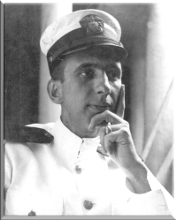
Commander Richard Wainwright, the son of Admiral Wainwright, was born in Washington, DC on 15 September 1881.
Commander Wainwright graduated from the US Naval Academy in 1903.
He served on board battleship USS Louisiana during the ships participation in the voyage of the Great White Fleet around the world from 1907 to 1909.
Wainwright was awarded the Medal of Honor for his outstanding conduct in battle while commanding a landing force from battleship Florida at Vera Cruz, Mexico, on 21 and 22 April 1914.
He retired from the Navy on physical disability on 3 March 1921 and died at Annapolis, MD., on 28 March 1944.

